|  |  |
| --- | --- |
| Name: Sayyed Sohail Rashid | Course Name: DC-LAB |
| Class: BE-CO | Batch: 01 |
| Roll no: 18CO48 | Experiment No: 04 |

Aim **:** To Implement the Bully Algorithm.

Code**:**

BullyAlgoExample2.java

import java.util.Scanner;

// create process class for creating a process having id and status class Process{

// declare variables public int id;

public String status;

// initialize variables using constructor public Process(int id){

this.id = id; this.status = "active";

}

}

// create class BullyAlgoExample2 for understanding the concept of Bully algorithm public class BullyAlgoExample2 {

// initialize variables and array Scanner sc;

Process[] processes; int n;

// initialize Scanner class object in constructor public BullyAlgoExample2(){

sc= new Scanner(System.in);

}

// create ring() method for initializing the ring

boolean higherProcesses = false;

// iterate all the processes

for(int i = idOfInitiator + 1; i< n; i++){ if(processes[i].status == "active"){

System.out.println("Process "+idOfInitiator+" Passes Election("+idOfInitiator+") message to process" +i);

// main() method start

public static void main(String[] args) {

// create instance of the BullyAlgoExample2 class BullyAlgoExample2 bully = new BullyAlgoExample2();

// call ring() and performElection() method bully.ring();

bully.performElection();

}

}

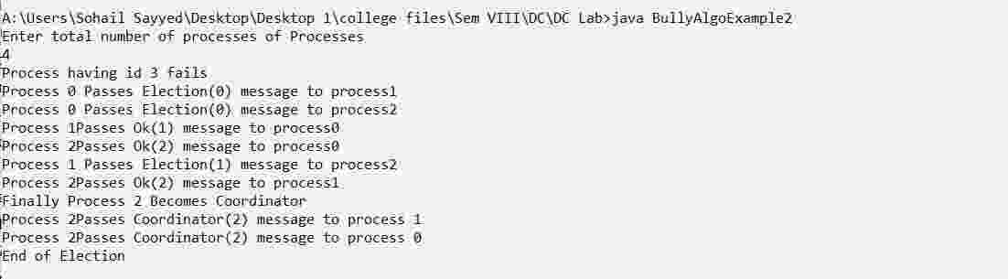

Conclusion**:**

Bully Algorithm has been executed successfully and gives the required output.